<https://github.com/sight-hkust/course-project-submission-template>

|  |
| --- |
| Design Solutions   * The evolution of the product (problems and situations) * The evaluation of the final prototype (solution) * Technologies involved in the product (solution) * How it is meeting the needs of the end user (solution - how, objectives) * Problems they had and how did they overcome those? (progress) * Sustainability (progress) * Sufficient information provided to carry this project in the future (progress) * Sufficient images and figures for explanations (progress) |
| User Experience **= 2.3 testing/feedback**   * How did they contact user to get feedbacks and comments? * How often did they contact them? * What are the changes they have done to the product based on user feedbacks? * How the user feedbacks help to have a better, sustainable solution |
| Implementation Plan/ Future plan, recommendations and conclusion   * What are the short term (less than 3 months) and long term plan for the project (Should have a clear and feasible timeline) * How is the product going to reach the end user? * In-line with local customs |

**Deadline : sunday night (23:30)**

1. Background

1.1. Situation description (Jaman)

1.2. Problems (Jaman)

1.3. System’s development

1.4. Progress of the project (Ian)

1.1 Situation description

Noticing that Hong Kong has the highest rate of myopia across the globe for kids at 6 years old. (Yuen, 2019) It intrigues us to further investigated various literature for more information. It shows that there is a rising prevalence of refractive errors among local primary school students. Therefore, we are interested to come up with a solution to ease the worsening trend.

We had the inspiration of building an eye care mobile application after listening to Mr. Dick Lo’s sharing on how to keep track on eye data may enable people to notice serious eye disease in advance. Since most of Hong Kong parents and children rely on the booklet provided by health department to record children’s health data. However, the booklet only serves as data recording purposes. It doesn’t enable parents or children to understand the meaning behind the data and the trend it displays. We considered there’s room of improvement such that we can build something for parents to monitor their kids’ vision change and equip parents with correct eye care information and habits such that their kids can also be well educated at their very young age. We believe that by building good eye-using habits at early days for the kids can help to relax the growing progression of refractive errors in Hong Kong.

1.2 Problems

Since there are many possibilities to tackle the phenomenon. We have to define problems that is within our reach. Two problems are defined as below:

* Lacking accessibility to their own eye data
* Lacking education on how to take care of their eyes

In Hong Kong, most people won’t keep longitudinal records of their eye data. Neither can they interpret and understand the trend of each data point nor its risk behind the progressions. That said, people in Hong Kong are not be able to access their own eye data.

Since children in primary school or kindergarten just start exposing to mobile devices. How they cultivate their habits in using these screen products may affect their eye health throughout along their life. However, lacking sufficient education and awareness on how to use their eyes correctly may pave the way for increasing risk of suffering from refractive errors.

These two problems contribute to our ideas in building an application and how we want to interactive with our users.

1.5. Objectives (Jaman)

Prior to our defined problems, we need some objectives to measure how effective and successful is our solution. Below are the 3 objectives:

* Improve parents’ accessibility of their kids’ eye data
* Improve parents’ intuition of their kids’ eye data
* Educate parents and kids about the importance of eye health

(Evoluton)

We first started working on this project in Fall 2019, back then we prepared a design prototype of our core functions (collecting and presenting data, patient-doctor connections, educative advice) using Sketch.

Then after we started this term, we made some basic wire diagrams using hand drawings and PowerPoint which also included the ideas that we have generated at the beginning

.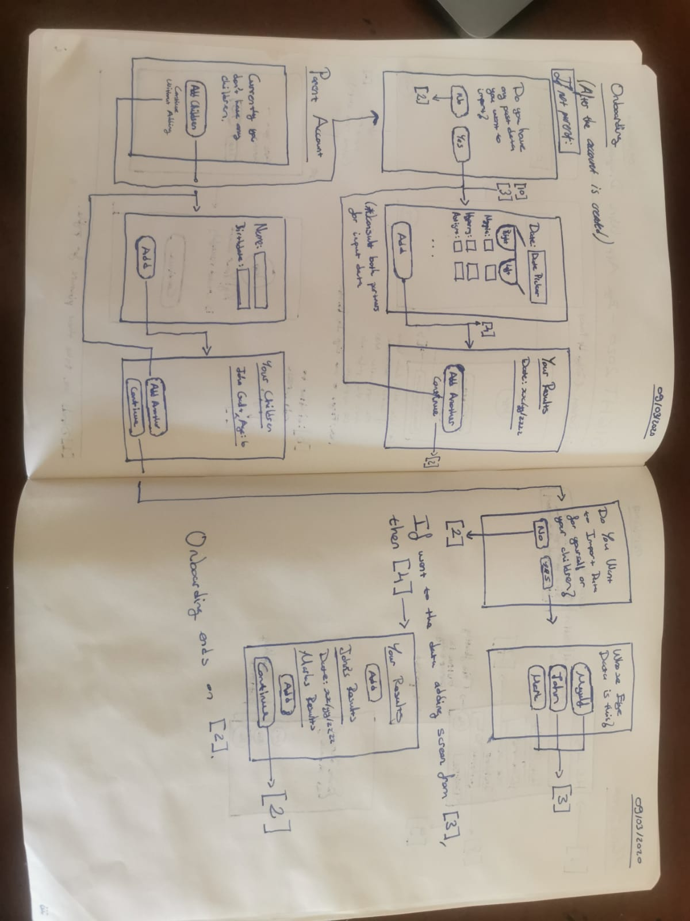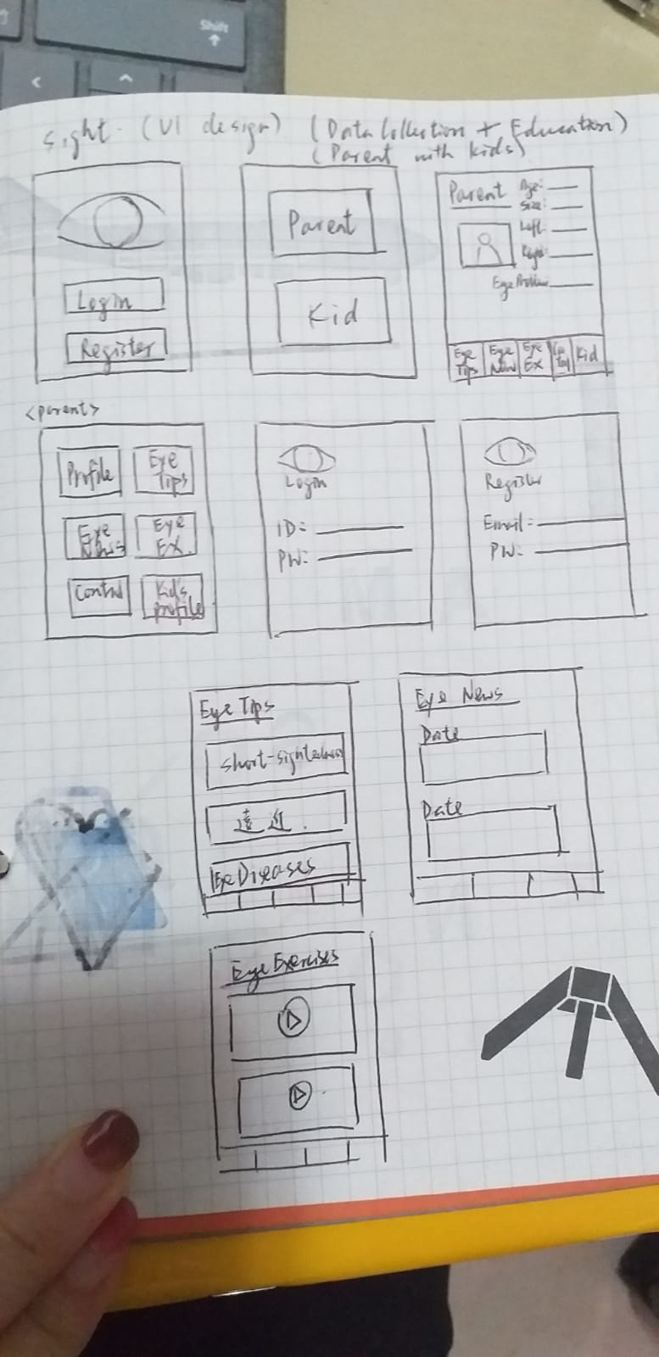

After our ideas started becoming more solid we put them down in Figma, meanwhile, we also started developing the skeleton of our application.

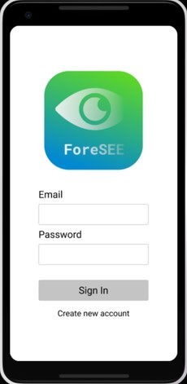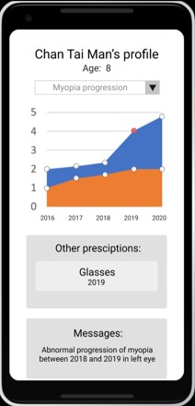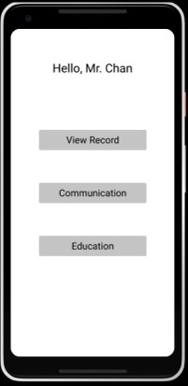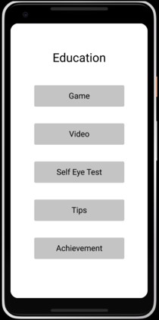

After having several meeting with our partners, we get a lot of suggestions and then decided to adjust some of the improper part in the figma. For example, our partner point out that in data recording and data visualization part, we have to follow the naming convention used by professionals, and the customer’s record is a little messy for both user and professionals. For the education part, our partner would like to have more interaction with users by answering their questions. Our partner commented that the self eye test can be a game with random test questions. It is advised to use more audio content in order to reduce screen time. We also make our interface more easily for user to use.

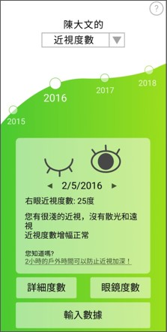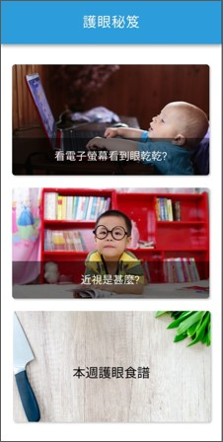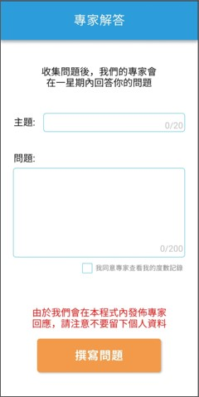

1.3. System’s development

Our application consists of three main components: **The application itself, the database, and the connection between them (API).**

1.3.1 The Application

We decided to use React Native for the development of our application, which is an open-source cross-platform development framework. React Native uses JSX, a version of Javascript, while developing.

Our application is structured as below:

1. The application starts from **App.js** file.
2. **App.js** only contains the “screens” in a **Stack Navigator** which is a navigation element of the react-navigation library.
3. **App.js** navigates the application to the **Login Screen**.
4. Each screen navigates between each other using the **navigation prop** passed by the **App.js** and they send information using **props** as well.

As React Native is open source, there are many open-source libraries which has been developed by the community. The libraries which we are using are below:

* **react-navigation**
* **react-native-community/checkbox**
* **react-native-localization**
* **react-native-sound**
* **react-native-chartkit & react-native-svg**

1.3.2 The Database

We are hosting our database at Amazon Web Services (AWS), we have used AWS as we thought it would be much more easier for the development process. The AWS service we are using is called Relational Database Service (RDS). We use **MySQL** in our database which is an open-source query language.

We are using **MySQL Workbench** to check our database

1.3.3 The REST API

We decided to write REST APIs to make requests in order to get and change data on the database from our application.

We are using AWS’s **Lambda** service, which basically runs your code in a serverless environment. To reach Lambda from the application we are using an open-source micro-framework called **Chalice,** which automatically configures the internet gateway for the Lambda when we change the code.

After the Lamda code is deployed with Chalice, we can send GET and POST requests to Lambda from the application.

2. Solutions and prototyping - ForeSee Application

2.1. Software development: ForeSee Mobile App

We used **Intellij Idea** for the development of the mobile application. The whole functions are written in JSX(a version of Java Script) and the styling (UI) is made using CSS like styling. Below is our **App.js,** the entry point of the whole application.

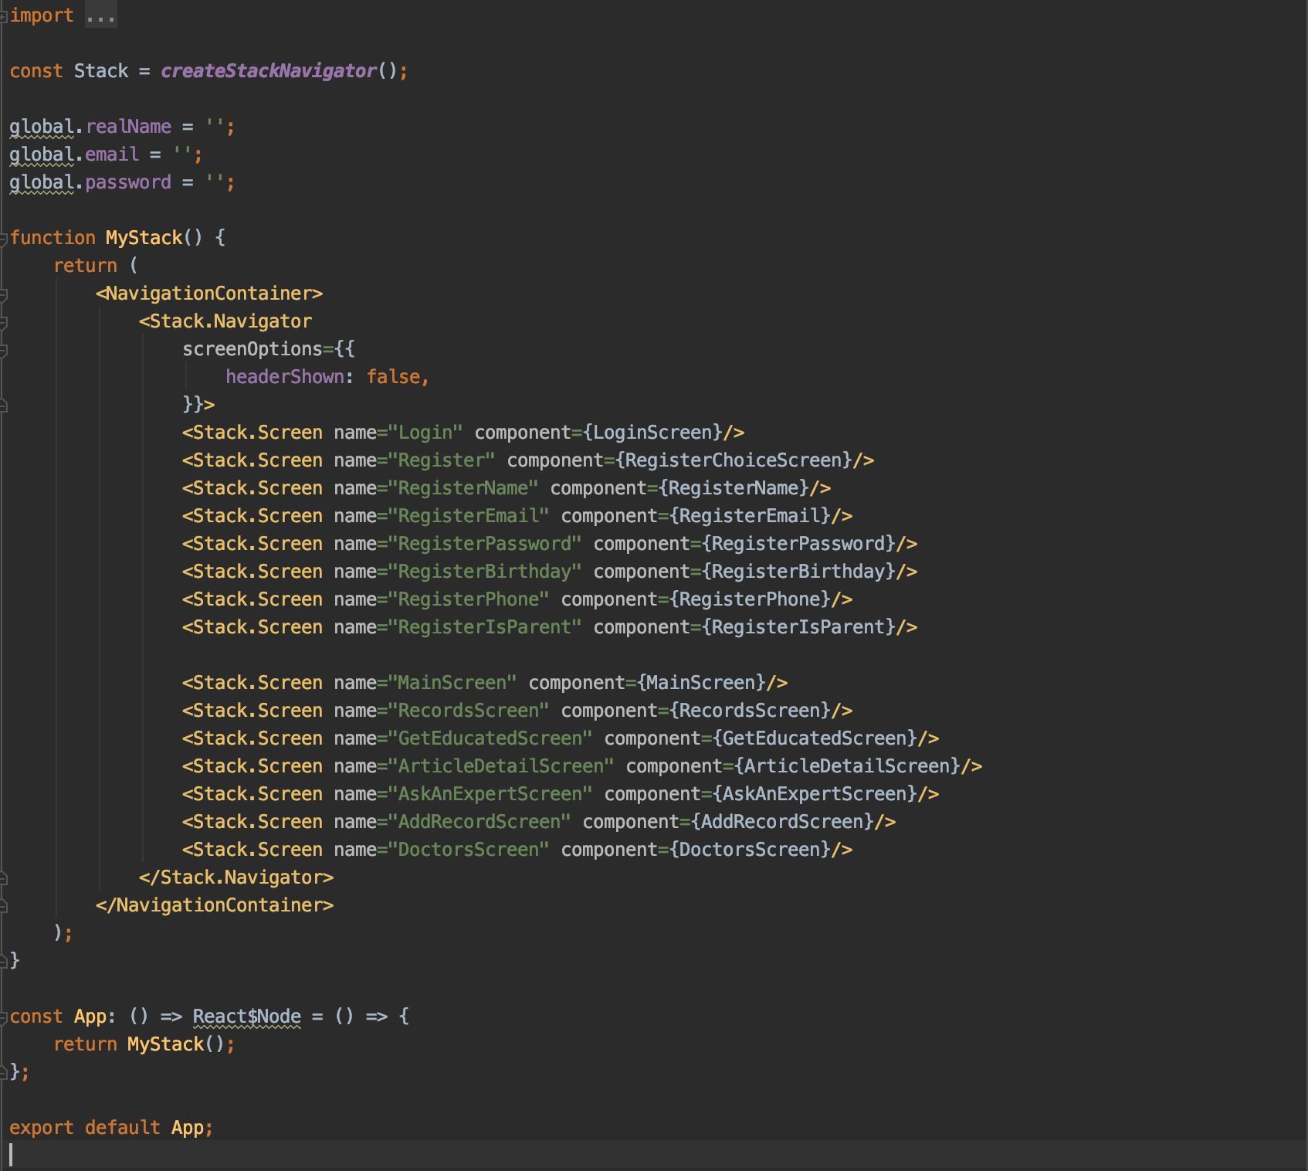

This stores all of our screens in a **Stack Navigator** which is a navigation element of **react-navigation** (an open source library). We use many open-source libraries like react-native-navigation and we have used node package manager(**npm**)in order to download them. In current state of the application all libraries can be installed using the

npm install

command as all of them are stored inside **package.json**.

The first screen the application goes is the **LoginScreen** which renders the code below:

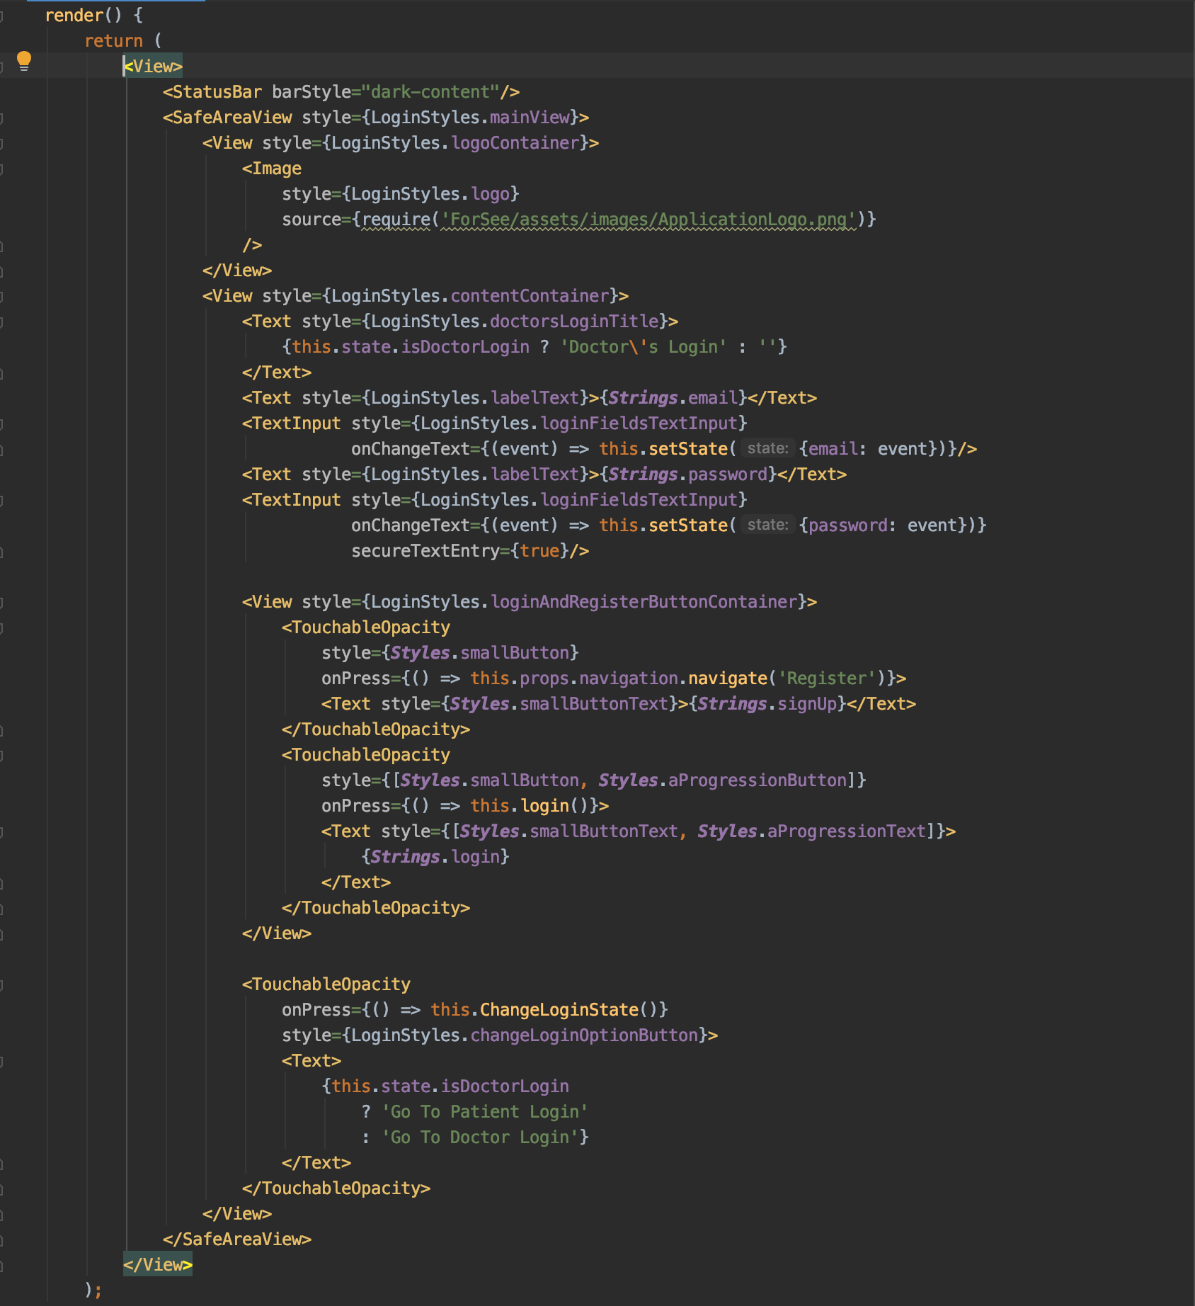

With the styling below: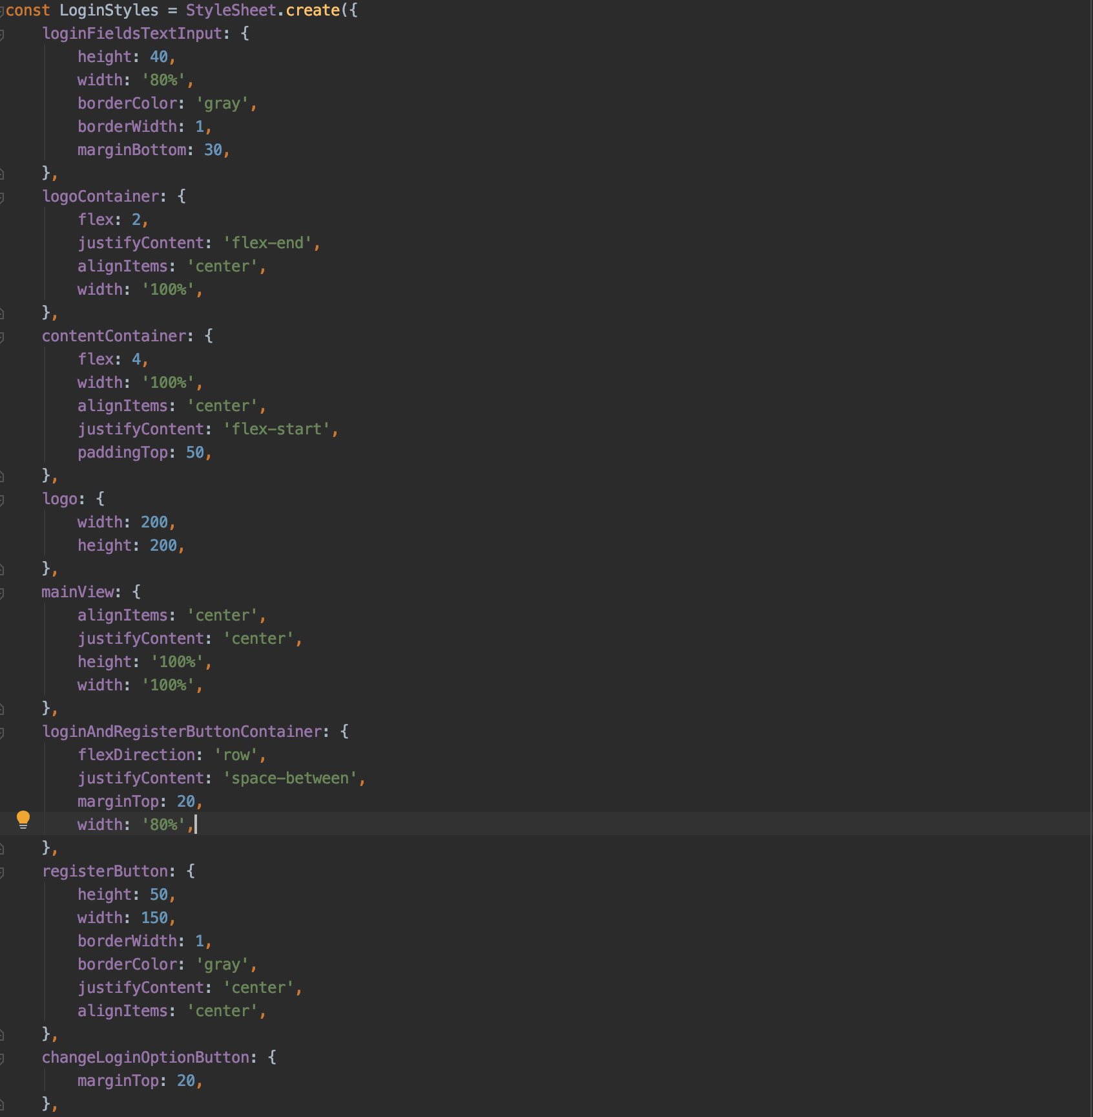

All these codes result in the following screen:

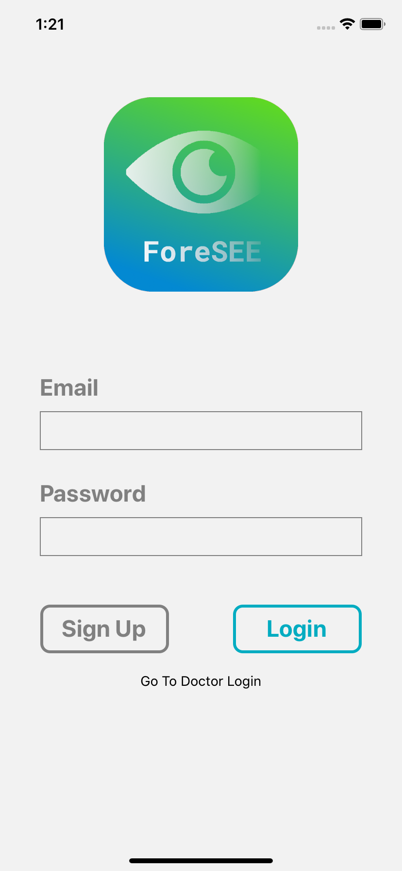

2.1.1. Flow of app (user journey) (Nora, Dogu)

2.1.2.Function [include UI design]

a)Data collection (record, visualization) (Nora)

b)Ask a professional ( Nora)

c)Articles and recipes (Ian)

d)Eye exercise (Karen)

e)Eye examination (Karen)

f) Achievement (Karen)

-2.1.3. Technical detail(e.g. set up of server etc.) (Dogu)

2.2. Partnership: professional supports (Dr Dick Lo, Professors every thursday), partners with eyestores (Jaman)

2.3 Testing/Feedback: Communications with Kelly/Dr. Yam, communication with parents/kids (Nora)

3. Implementation plan

3.1. Short-term plan (Karen)

3.2. Long-term plan (Nora)

3.3. Methods to reach end users (Karen)

3.4. in-line with local customs (Hong Kong, 2 languages) (Jaman)

4. Future outlook

Target Market and customers (Jaman)

Sustainability (how we keep it for a long time) (Ian)

5.Conclusion (Jaman)

6. Appendix (Do our own appendix) (put as many as you can!!!!!)

(e.g. pictures, references, contact lists, all notes and minutes)

There are definitely things that you guys did and MedEasy did not do, please include them as well???? <==What does this mean(?__?)

**Final Report**

1. Background

1.1. Situation description (Jaman)

1.2. Problems (Jaman)

1.3. System’s development

1.4. Progress of the project (Ian)

1.5. Objectives (Jaman)

2. Solutions and prototyping - ForeSee Application

2.1. Software development: ForeSee Mobile App

-2.1.1. Flow of app (user journey) (Nora, Dogu)

-2.1.2.Function [include UI design]

a)Data collection (record, visualization) (Nora)

b)Ask a professional ( Nora)

c)Articles and recipes (Ian)

The articles and recipes aim to make the user learn more about eye-health knowledge. In the articles part, we found some articles and then write some summary of the articles( around 100 to 200 words). After that, we record the voice of the summary so that the user can learn the knowledge of eye-health by playing the audio and reduce the screen time in order to protect their eyes from the blue light.We also provide the sources of those articles so that if some users are interested in the content of the articles, they can just go through it directly.

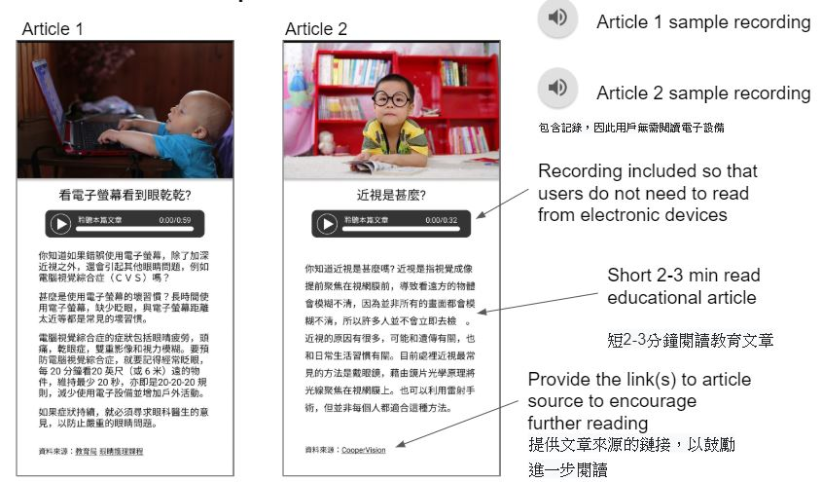

As for the recipe part, we come up with this idea since that it can attract some “mother users”. In the recipe, we not only show the progress of the cuisine, but also point out what ingredient benefits eyes so that the user can cook the meal and the learn some information at the same time.we also put the source of the recipe and we plan to renew the recipe once a week.

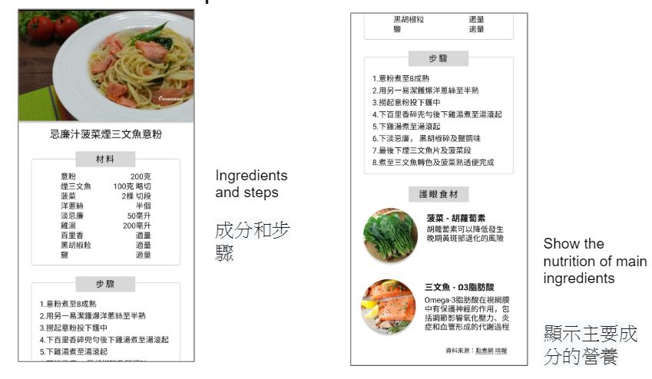

d)Eye exercise (Karen)

The eye exercise aims to let users exercise their eyes by following our audio instruction. It can protect and relax users’ eyes when they feel tired in working and studying. The strength is that it can reduce screen time with 3D audio experience that consists of audio instruction and relaxing music as their eyes can look away from their electronic devices or books for a certain time. While closing their eyes, they can be able to feel the sound with spatial arrangement. For example, they can hear the sound coming from the left when they are told to rotate their eyes to the left and they can hear the sound coming from the right when they are told to rotate their eyes to the right. However, the front and back side effect are not included yet. Its current limitation is that it requires users’ headphone to enjoy the full effect.

UI design:

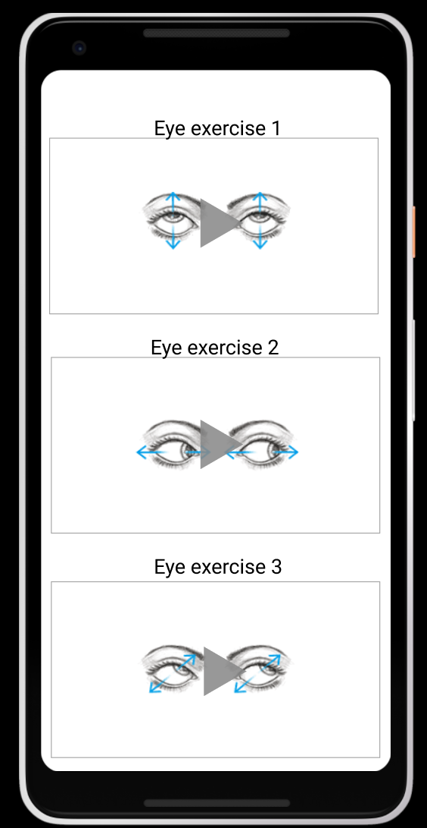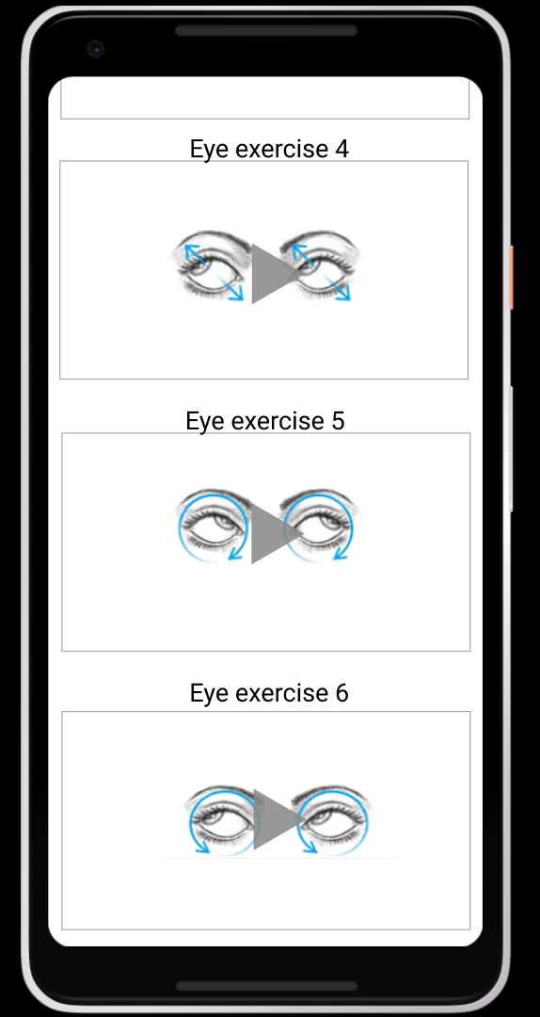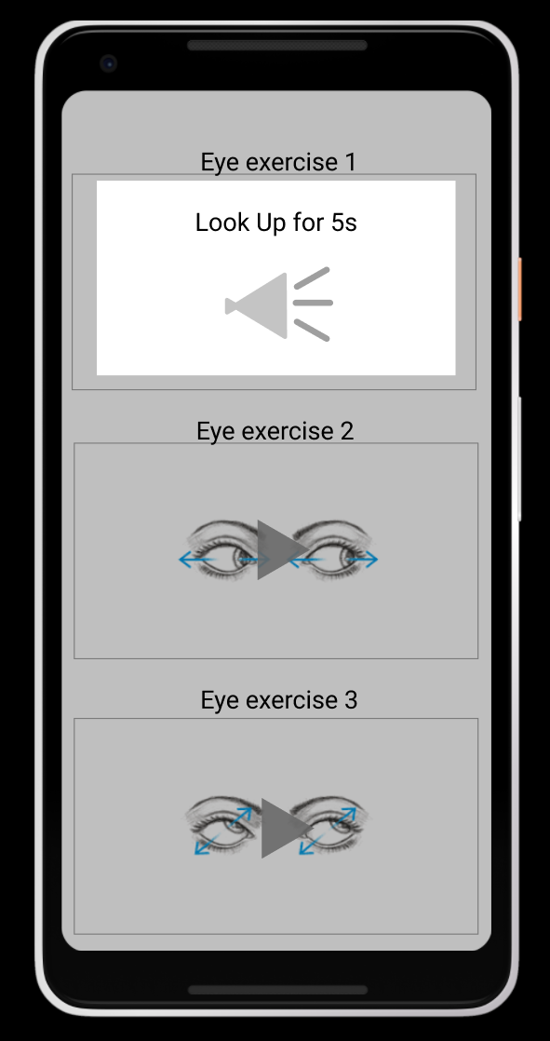

(Page 1) (Page 2) (Page 3)

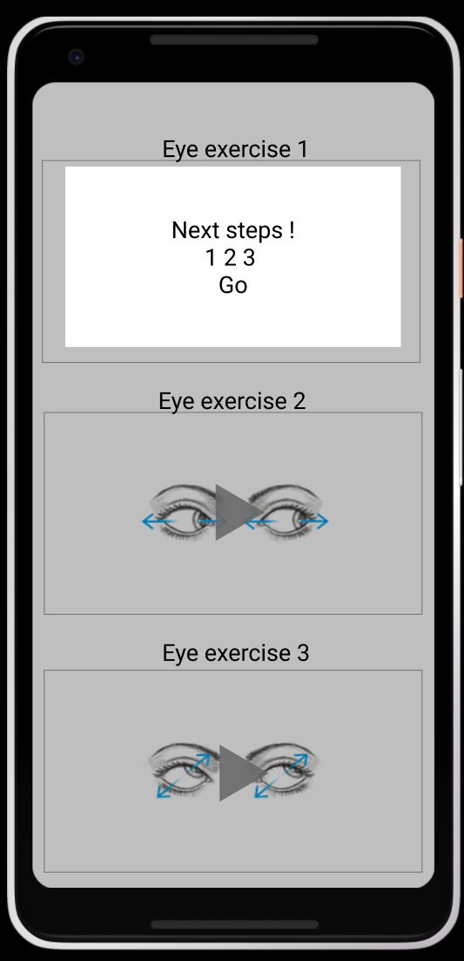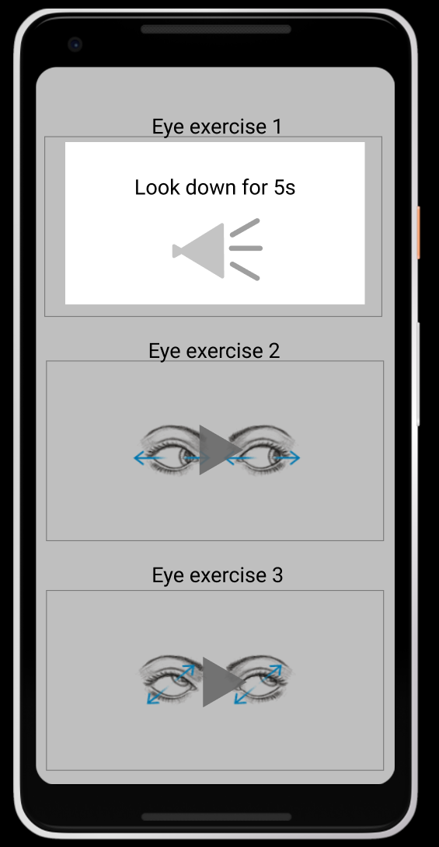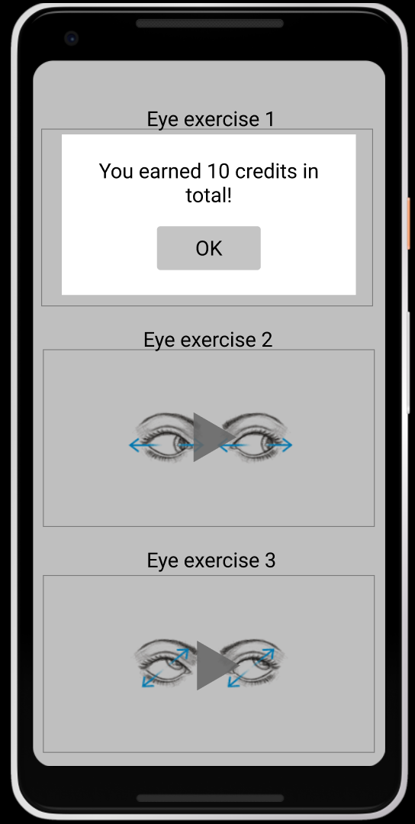

(Page 4) (Page 5) (Page 6)

After pressing the “play” button in the middle of box, it will give audio instruction automatically. For example, in eye exercise 1, users will be told to look up their eyes for 5 seconds by following the counting from the audio instruction. Then, they will be instructed to be ready for the next steps by listening to this “next steps! 1, 2, 3 Go!” instructioin. They were told to look down for 5 seconds. After the whole eye exercise, they will be able to gain the credits from our system for earning rewards in the future.

About the detail of the whole eye exercises, the total process is 200 seconds that is around 3.3 minutes. There are 10 steps in total with voice instruction and relaxing music. Here are the steps in detail:

|  |  |
| --- | --- |
| 1 | Close your eyes (20s) |
| 2 | Look at the farthest object (at least 20ft 6m) [prefer green object] (20s) |
| 3 | Look up (5s), Look down (5s), Look left (5s), Look right (5s) |
| 4 | Look top left and down right (5s), Look top right and down left (5s), Look down left and top right (5s), Look down right and top left (5s) |
| 5 | Rotate clockwise (10s), Rotate anticlockwise (10s) |
| 6 | Look at far object (5s), Look at close object (5s), Look at far object (5s), Look at close object (5s) |
| 7 | Close your eyes again (20s) |
| 8 | While closing your eyes: Turn your eyeballs up (5s), Turn your eyeballs down (5s), Turn your eyeballs left (5s), Turn your eyeballs right (5s) |
| 9 | While closing your eyes: Rotate your eyeballs clockwise (10s), Rotate your eyeballs anticlockwise (10s) |
| 10 | Eye Open and close (10s), Close your eyes and Relax (10s) |

After this eye exercise, users will feel relaxed and their eyes will be comforted by our soft audio instruction and music. If they do this eye exercises regularly, their eyes can be protected and they can be able to earn some credits and rewards from us such as some coupons of an eye store.

e)Eye examination (Karen)

The eye examination is told to be a designable feature as it can allow parents to check their kids’ eye health regularly, especially in this quarantine period due to coronavirus. To prevent the spread of diseases, people were not encouraged to go outside for eye check-up in this situation. Also, it is convenient for some busy parents who do not have time to go eye store to check their kids’ eyes regularly due to their job. As the eye development of kids is rapid and changes fast, parents should be aware of kids’ eyes. Moreover, people spend lots of time in electronic devices nowadays without concerning their eye health. This eye examination in app can be helpful for these situations. This eye examination can help to check their eye performance by the help of family members. However, it is not an accurate method which cannot be replaced by the eye check-up from professional optometrists. The disclaimer will be put in this session such as “it cannot replace the eye check-up from professional optometrists”. It can be a reference for users to let them aware of their eye health and performance.

The distance of this eye examination is 20 feet (6 meters) away (MedlinePlus, 2020). The parents will act as an eye examiner who check the eye performance of their kids or other family members who act as a patient. Their kids or other family members will be instructed by parents who will hold the phone with the eye examination charts (Eye Test Menu). There are 6 eye test steps in total with different sizes and various directions of “letter E” such as “upward”, “downward”, “left hand side” and “right hand side”. The total process of eye examination is around 6 to 10 minutes.

Here is showing you the 3 eye test steps:

UI design:

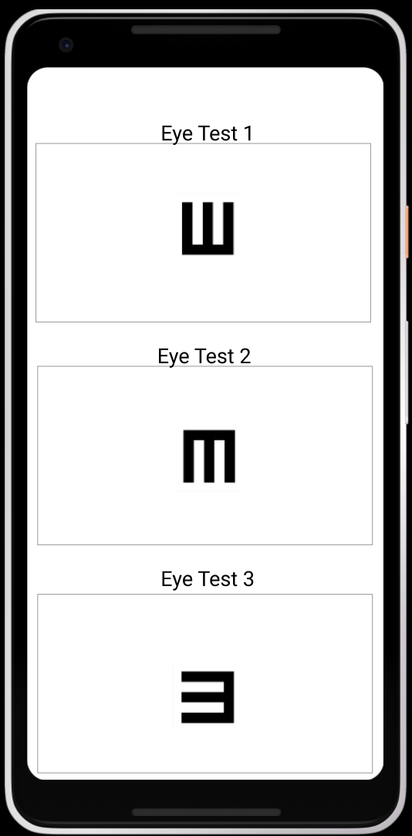

(Page 1) (Eye Test Menu)

When pressing the “letter E” of eye test 1, page 2 image will be appeared.

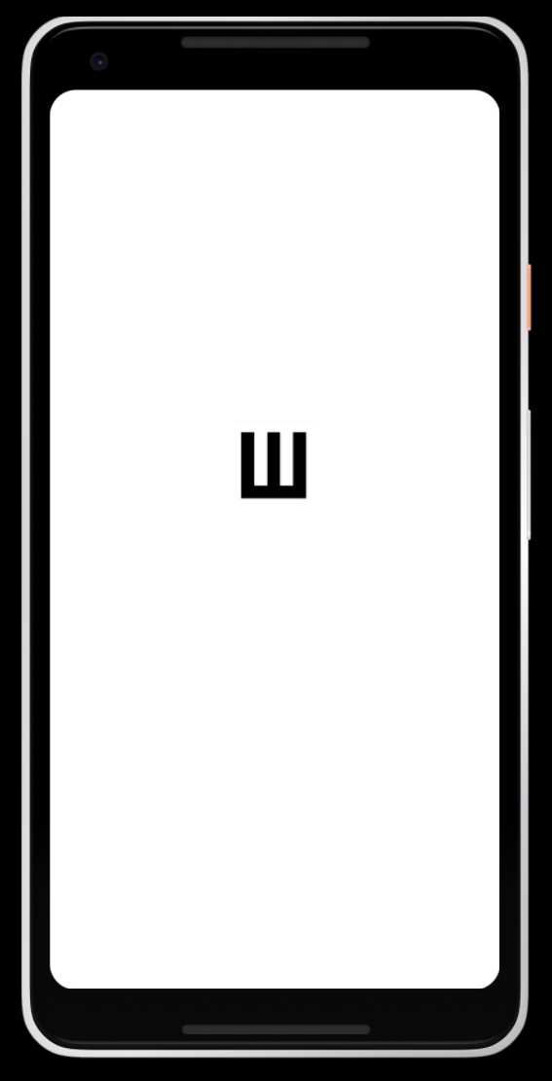

(Page 2) (Eye Test 1)

When users are in this page, the eye examination can be ready to perform after the distance between eye examiner and patient are in 20 feet (6 meters) away. The eye examiner is responsible for swapping the “letter E” directionally that is told by the patient.

Here is the process of Eye Test 1 (Page 2):

Patient (e.g. kids/other family members): say “upward”

Eye examiner (e.g. parent): swap the “letter E” from the bottom to the top, then it will go to the eye test menu (page 1) automatically.

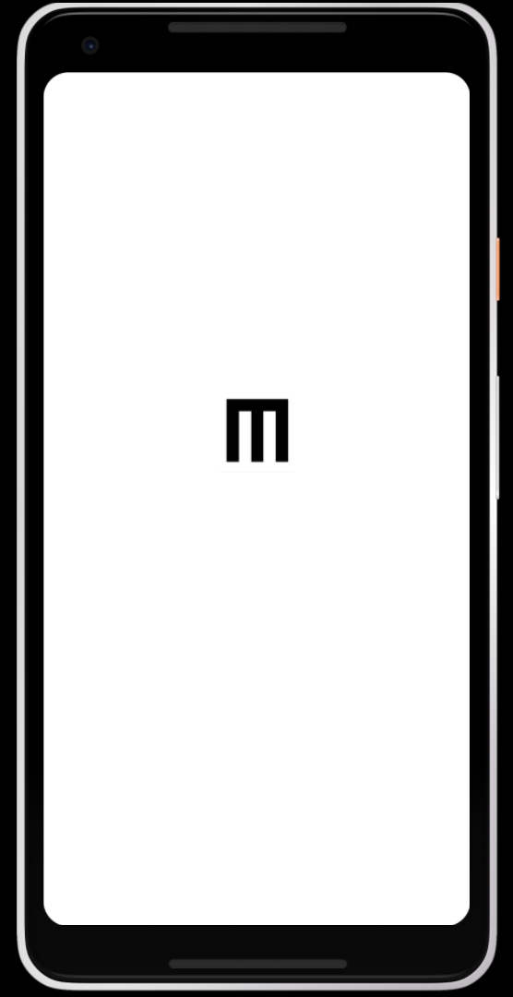

(Page 3) (Eye Test 2)

Here is the process of Eye Test 2 (Page 3):

Patient (e.g. kids/other family members): say “downward”

Eye examiner (e.g. parent): swap the “letter E” from the top to the bottom, then it will go to the eye test menu (page 1) automatically.

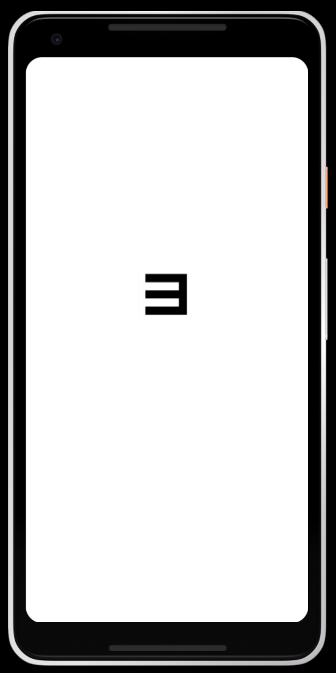

(Page 4) (Eye Test 3)

Here is the process of Eye Test 3 (Page 4):

Patient (e.g. kids/other family members): say “left hand side”

Eye examiner (e.g. parent): swap the “letter E” from the right to the left, then it will go to the eye test menu (page 1) automatically.

When patient cannot be able to see some “letter E”, he or she cannot give the directional signal to eye examiner. After counting 10 seconds by eye examiner, patient who cannot be able to see the “letter E” has to say “I cannot see this”. Then, eye examiner can press the button of the right top corner for notes in order to remember patient cannot be able to see that “letter E”. The right top corner button will be made in the later stage. It will look like this 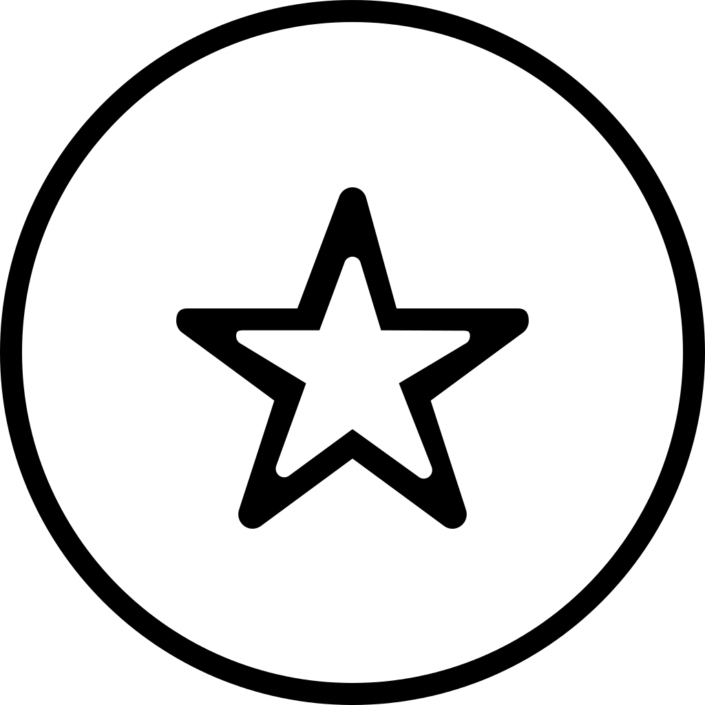. After pressing this button for remembering, the eye examiner has to swap that “letter E” by herself or himself and allow the progress of eye test to be continued and finish the 6 eye test steps in total with patient.

f) Achievement (Karen)

The achievement aims to be an incentive to encourage users to build up an eye care habit in order to take care of their eyes. The achievement page will provide certain number of tasks for people to complete. Luckily, we have a partnership with an eye glasses shop which gives us some coupons. However, the current limitation is that there is still lack of support from local eye stores. About the achievement page, the item list will be just like a checklist (To-do-lists). The little “certificate” of achievement name such as eye tips expert, eye health chef, book expert will be given to the users who performed the tasks completely. The little “certificate” is the badges which is a visual representation of the achievement gained by users. The method of earning credits is to do tasks (daily & long-term elements) with 3 levels which are easy, moderate and challenging that will be depended on the time consumption. After gaining a certain credits that were designed by us, a coupon will be as a reward to them. The tasks will be modified based on the trend of the society.

|  |  |  |
| --- | --- | --- |
| Easy | Moderate | Challenging |
| less time consuming | time consuming | more time consuming |

Here are the examples of tasks if we designed 100 credits for 1 coupon:

|  |  |
| --- | --- |
| Daily Tasks | Long Terms (e.g. 1 year goal) |
| Listen 3 articles | Ask 2 questions to Doctor |
| Do 3 eye exericses | Record your own data regularly |
| Cook 1 meal | Record your eye-check up data |
| Input your 1 meal pic | Do questionarie (random) |
| Do outdoor activities | Do a whole detail questionaire each half year |
| Input exercise pic | Stop using your phone for 1 day (weekend’holiday) |
| Register/go 1 eye check up | Do 12 exercises regularly |
| Invite ppl to download | Do eye exercises regularly |
| Input eye health tips | Cook eye health meal |
| Share 1 eye health routine by post | Read 12 short articles |

UI design:

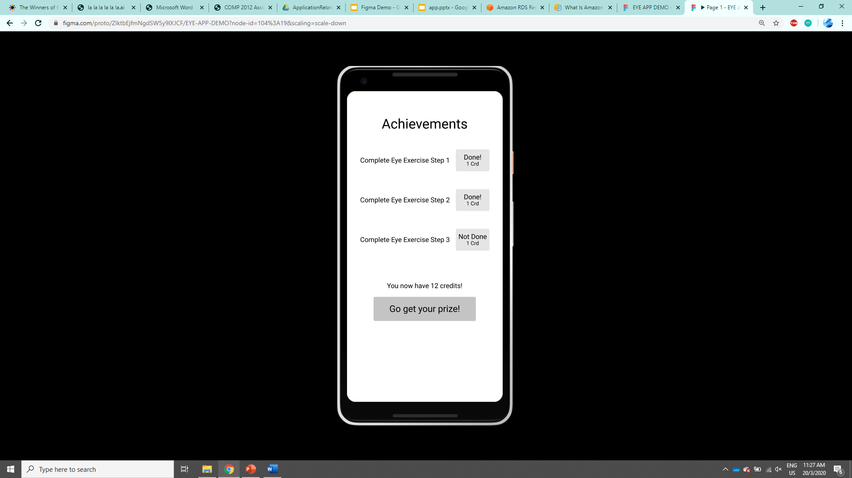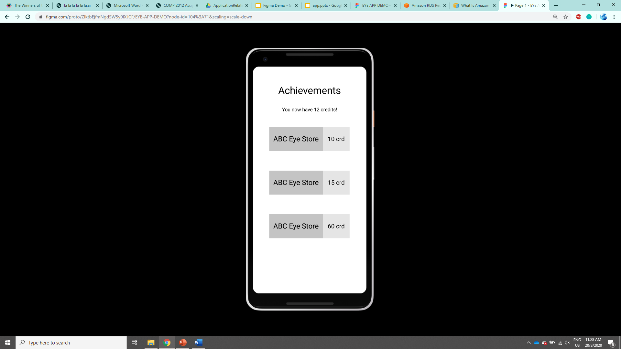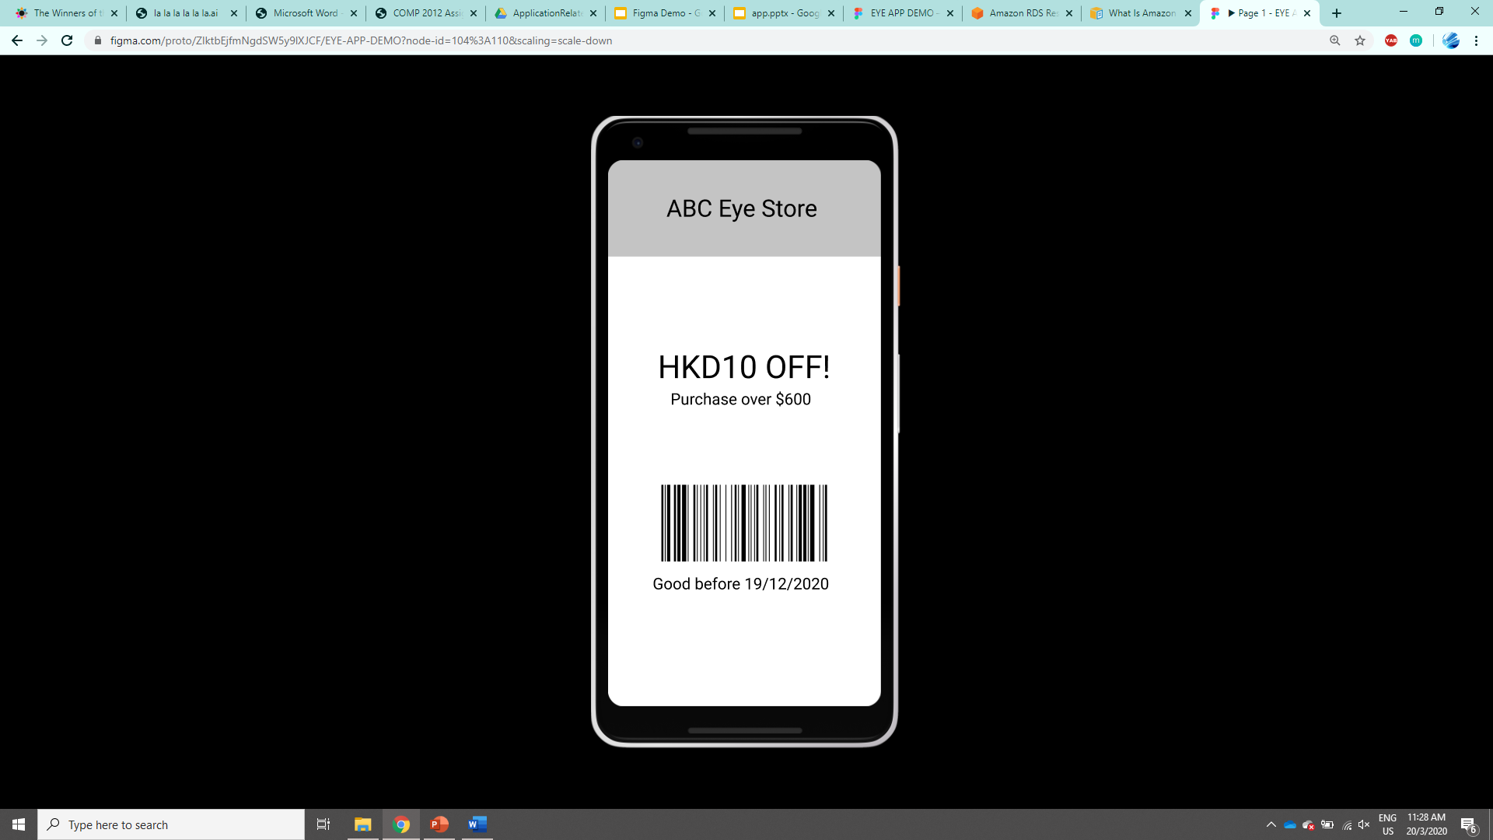

(Page 1) (Page 2) (Page 3)

In page1, your credits and achievements will be recorded. In page 2, it shows what coupon that you can use according to your credits. In page 3, it is the enlargement of a electronic coupon which will be useful for shopper to scan this barcode as a record in their company to show that users utilize this app to purchase things in that eye store.

-2.1.3. Technical detail(e.g. set up of server etc.) (Dogu)

2.2. Partnership: professional supports (Dr Dick Lo, Professors every thursday), partners with eyestores (Jaman)

2.2 Partnership: professional supports

In order to make sure accuracy of information provide by our application as well as to ensure outreach of our application, we cooperate with an optician and a social worker.

On one hand, Mr. Dick Lo is our optician partner. We have had one meeting with him at the initial stage of application development. His professional advice helps us to tune our app into more professional friendly and accurate. Also, he is willing to support our app by donating 100 free lenses to us such that we can use the free lenses as a gift to attract first group of our users.

On the other hand, connection with Kelly, who is a professional social worker, helps us to reach out to parents’ group in Hong Kong. Since we are still at development stage for our app, Kelly’s connection enables us to understand parents’ concerns on their kids’ eye health before launching of our application.

2.3 Testing/Feedback: Communications with Kelly/Dr. Yam, communication with parents/kids (Nora)

3. Implementation plan

3.1. Short-term plan (Karen)

About our short-term plan, ForeSee is planned to be available on Google Play and promoted on Bady-Kingdom or other forums in the coming summer.

Apart from that, we plan to recruit around 100 users for testing such as social worker, professional optometrists and parents with kids through social media and online forum. The testing period will be conducted within 1 month. We obtain their feedback and evaluate their behavior change by asking them to fill in three questionnaires which includes two behavior evaluation questionnaires (before and after) and one on user experience.

About the timeline:

In June, we will design those questionnaires, promote our ForeSee app in social media such as instagram, youtube and facebook. In the meanwhile, we will continue to develop and improve the UI and launch professional side to test data recording function, find potential professional users or partners for answering Q&A session from our app, seek for the help from local eye stores and contact the potential partners from eye associations or societies broadly to increase our networking and enhance our brand awareness.

In July, we will launch the beta version of the application on Google Play store and ios app store.

In August, we will receive questionnaires, evaluate behavior change and feedbacks and start the second round of design process.

Thus, our short-term plan is mainly on evaluation or validation, putting it into the market, promotion and seeking for partnership.

3.2. Long-term plan (Nora)

3.3. Methods to reach end users (Karen)

To reach end users, we planned to promote in all Hong Kong eye stores, public eye health clinics by putting posters or booth there. Also, we planned to promote in kindergarten, primary and secondary school by talks and putting booth there in their open days or special dates. We hope to connect with parents more through school. Moreover, we planned to be volunteer to conduct some surveys with our end users on the street or at their home.

3.4. in-line with local customs (Hong Kong, 2 languages) (Jaman)

3.4 In-line with local customs

Given that we are targeting at local parents who have children age 6-8. We need to adjust our application development as well as promotion strategy in order to attract our targets. For instance, we provide both English and Chinese version of our application. Parents can listen to Cantonese recordings of our eye health-related recipes, articles and eye exercise.

In addition, we apply role play format of presentation during outreach to parents. We make use of Hong Kong lifestyle related conversations to explain how our applications can help local parents.

4. Future outlook

Target Market and customers (Jaman)

4.1 Target Market and customers

Our target customers are local parents who have children age 6-8

4.2 Sustainability (how we keep it for a long time) (Ian)

5.Conclusion (Jaman)

6. Appendix (Do our own appendix) (put as many as you can!!!!!)

(e.g. pictures, references, contact lists, all notes and minutes)

<https://medlineplus.gov/ency/article/003396.htm> (MedlinePlus, 2020)